A minor Project Midterm Report on

**EXAM SEAT ALLOCATION SYSTEM**

Submitted in Partial Fulfillment of the Requirements for

The Degree of **BACHELOR OF ENGINEERING IN INFORMATION**

**TECHNOLOGY**

Under Pokhara University

Submitted by:

**Bikash Thapa Magar,15458**

**Santosh Thapa Magar,15478**

Under the supervision of

Er.Satish Kumar Karn

Date:

29-11-2018

_ _ _

_ _ _

**ç**



**Department of Information Technology**

**NEPAL COLLEGE OF INFORMATION TECHNOLOGY**

Balkumari, Lalitpur, Nepal

ABSTRACT

*This project “EXAM SEAT ALLOCATION SYSTEM” is a web based application which generates seat plan for the examination in any college,university and other organizations where written exam is needed. This application takes the student information which processes and generates seat plan for different departments. In this system,two module is present,one is admin and another is user or student module. The admin module is accessed by the organization’s exam department who are responsible for the seat allocation process. The existing pattern is so time consuming as well as tedious one. The committee should know all about the halls as well as room capacity. The excel sheet provide alternative way for such tedious work and also stores the data provided in database for future use also. This system is based on php and Mysql is used for the database purpose.*

*Keyword:****php, Mysql, modules, seat allocation***

I

TABLE OF CONTENTS

1. INTRODUCTION…………………………………………...…………………….……………...1
2. PROBLEM STATEMENT………………………………………………………………………...2
3. PROJECT OBJECTIVE…………………...………..…..…………………………….…………...3
4. SCOPE AND LIMITATION………………………………………………………………………4

5.LITERATURE REVIEW…………………………………………………………………………..5

1. METHODOLOGY………………………………………………………………………………...6 6.1.SOFTWARE DEVELOPMENT LIFE CYCLE …………………..………..………………..6 6.1.1. REQUIREMENT ANALYSIS…………………………….…………...……………...6

6.1.2. DESIGN PHASE…………………………………………..…………………………..7

6.1.3. CODING PHASE………………....…………………………….…………………….7

6.1.4. TESTING PHASE……………………………………………………………….…….7

6.2. SOFTWARE SPECIFICATION……..…………………………………………..….…..…….8

7.SYSTEM MODEL AND UML DIAGRAMS….…………………………………...…….………..9

7.1 CONTEXT DIAGRAM……………….…………………………………………………9

7.2 DATA FLOW DIAGRAM………………………………………………………………..9

7.3 USE CASE DIAGRAM…..…………………………………………………………….11

7.4 ACTIVITY DIAGRAM…..……………………………………………………………..12

7.5 SEQUENCE DIAGRAM.……………………..………………………………………..13

7.6 ER DIAGRAM………………….………………………………………….…………...14

7.7 DOMAIN MODEL……………………………………………………….…………….15

8.SECURING DATA IN WEB…………………………………………………….………………..16

9.ALGORITHMS USED…………………………………………………………………………...17

10.TASK DONE SO FAR……………………………………………………………….………....18

1. PROPOSED DELIVERABLES…………………………………………………….…………..19

II

12.TASK REMAINING………………………………………..…………………………………...20

13.PROJECT TASK AND TIME SCHEDULE……….....………………………………….……...20

13.1 GANTT CHART……………………………………………………………..……….…...22

14.REFERENCES………………………………………………………………………………..…24

III

LIST OF FIGURES

Figure 1:Iterative model of Software Development Life Cycle……………………………………6

Figure 2:Context Diagram ………………………………………………………………………....9

Figure 3:DFD for Admin………………………………………………………………………….10

Figure 4:DFD for User ...........................................................................................................….…..10

Figure 5:Use Case Diagram ............................................................................................. ……..…...11

Figure 6:Activity Diagram for Admin ...........................................................................………....... 12

Figure 7:Activity Diagram for user...........................................................................................….... 12

Figure 8:Sequence Diagram for login………………………………………………………………13

Figure 9:Sequence Diagram for seat allocation……………………………………………………..13

Figure 10:ER Diagram……………………………………………………………………………...14

Figure 11:Domain Model…………………………………………………………………………15

IV

LIST OF TABLES

Table 1: Project task and time schedule………………………………………………………………………………………18

Table 2: Team member and divided roles……………………………………………………………………………………19

Table 3: Gantt chart first phase……………………………………………………………………………………………………20

Table 4: Gantt chart second phase………………………………………………………………………………………………20

Table 5: Gantt chart third phase……………………………………………………………………………………………………21

V

LIST OF ABBREVIATIONS

**DFD** Data Flow Diagram

**ER** Entity Relationship

**HTML** Hypertext Markup Language

**SQL** Structured Query Language

**UML** Unified Modeling Language

**MD5** Message Digest 5

VI

1.INTRODUCTION

Exam seat allocation system is a web based application developed for those organization where written examination is taken. The main aim of developing this system is to provide easy access to the data of each and every people in that specific organization. This system helps to keep track of available halls to the admin and to measure current seat capacity. In each and every institution(schools,colleges,universities) there are hundreds of students and each students data is very important for that instiute. Hundreds of students in different departments need to give written exam frequently. So,to simplify the seat allocation task,this system is very useful. Institute need to keep accurate records of each students and keeping records in paper is trustworthy now-a-days .This system solves that problem as well.

There is two module in this system,admin and user module. The admin module is used by the organization administration department and user modules are all for the students. In admin module,the admin first stores the details of all students in the database by providing the excel file that stores the data of all students. Storing the data of each students in database one at time so tedious one so this simplifies that task too. The existing system uses manual processes to store data of students. The main task of admin is that they should create the xml file in a predefined order as given in the system. Then the admin sees the available rooms and capacity of that available rooms. Then the admin allocates seats according to student’s departments for the examination. Then the admin saves the seat allocation in database. The admin can also access to the students information and can update the data if necessary. The students can login to the system and can see the room allocation.

1

2.PROBLEM STATEMENT

The management task has always been difficult for most of the people. The existing pattern in seat allocation process is too time consuming as well. There is also lack of data security too. This system provides stable database and time and effort is less with comparison to the existing pattern. The data is secured and cannot be accessed without permission. The other problem might be unstable system,as this project is developed in php, there is no lack of system outdate.

2

3.PROJECT OBJECTIVE

The main focus and aim in developing this projects are:

* Upload students information in the form of excel sheet as suggested in system and with same pattern and generate seat allocation according to the different departments.
* Ensure data security in open-environment.
* Easy access to seat allocation for all students.

3

4.SCOPE AND LIMITATION

SCOPE

* Information of students can be uploaded by excel sheet as prescribed pattern which saves most of time. While the inserting students data manually takes too much time which is so tedious too.
* Can be used in any colleges,schools as well as universities where allocating seat for different department is main.
* Can be used to stores data of student and can be changed later on.

LIMITATION

* The administration department should choose those administrators who can prepare excel sheet.
* The prescribed pattern should be followed which sometimes confuses the administrator.
* The students data should be accurate as well as data of all students should be in excel sheet which sometimes may left those students whose data are unavailable during room allocation.

4

5.LITERATURE REVIEW

This section consists of the literature study on the exam seat allocation system . Many colleges and universities are using these type of system for the seat allocation process . Despite of being behind in technical field like other developed countries,our local colleges are also using these type of system for the better accuracy within less time than before.

In our College too,Our Respected sir Dr . Roshan chitrakar implemented such system almost 10 years ago .The system is good and the result is accurate as well . Inspite of having such system ,we students must rely on the notice board for the search of room . The existing system in our College is stand alone application or can simply known as desktop application where the data loss and data damage is rare . If the application can be made online then the dependency on the college computers might be less and the student might get benefit from it if it can be run in smoother way with securing data.

5

6.METHODOLOGY

We have planned to work following these methodologies for the application of knowledge, skills and technique to meet the requirement of our project.

6.1. SOFTWARE DEVELOPMENT LIFE CYCLE

The framework we will be using for developing this project is iterative model. In this model, a simple and primitive implementation of very small set of software requirement is done at first, which is followed by the iterative enhancement in the primitive model until all requirements are fulfilled by acknowledging the feedback from the previous model. The following sub section briefly describe various phase in iterative model of SDLC that was applied in the development of system.

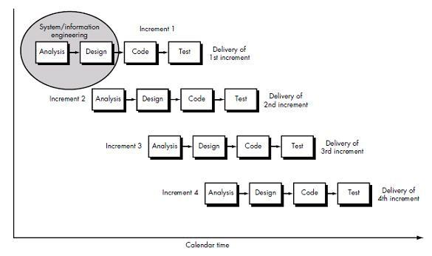

Figure 1:Iterative model in software development life cycle

6.1.1. REQUIREMENT ANALYSIS:

In this phase, analysis will be performed in order to find out the requirements of the system. The outcome of this phase would be a system requirement specifications.

6

6.1.2. DESIGN PHASE:

In this phase the system requirement specifications would be translated into the system design. Context diagram, data flow diagram, entity-relationship diagram, use case diagram, sequence diagram ,domain model and class diagram will be developed.

6.1.3. CODING PHASE:

In this phase coding will be done according to the design and a working system will be developed by the end of the process.

6.1.4. TESTING PHASE:

In this phase the system will be tested with each testing list of changes to the system developed, is suggested and the change will be applied to the software and the software would be delivered as a successive increment until a satisfying system is achieved.

6.2. SOFTWARE SPECIFICATION

**HTML:**

It is the standard markup language used to create web Pages. HTML is written in the form of HTML elements consisting of tags enclosed in angle brackets (e.g. <html>). HTMlL is skeleton of the system.

**CASCADING STYLE SHEETS** (**CSS**):

It is a style sheet language used for describing the look and formatting of a document written in a markup language .While most often used to style web pages and interfaces written in HTML the language can be applied to any kind of XML document,. CSS is to make the User Interface more attractive as well as to add responsiveness to the system so that the system is much more comfortable to use.

7

MYSQL:

MySQL is developed, distributed, and supported by Oracle Corporation. MySQL is a database system used on the web it runs on a server. MySQL is ideal for both small and large applications. It is very fast, reliable, and easy to use. It supports standard SQL. MySQL can be compiled on a number of platforms. The data in MySQL is stored in tables. A table is a collection of related data, and it consists of columns and rows. Databases are useful when storing information categorically. It is much more easier and faster to manipulate data in MySQL.

JAVASCRIPT:

JavaScript is the scripting language of the Web. All modern HTML pages are using JavaScript. A scripting language is a lightweight programming language. JavaScript code can be inserted into any HTML page, and it can be executed by all types of web browsers. JavaScript is easy to learn as well easy to implement.

PHP:

PHP is an acronym for "PHP Hypertext Preprocessor”. it is a widely-used, open source scripting language. It scripts are executed on the server. It costs nothing, it is free to download and use.

SOFTWARE REQUIREMENTS:

OPERATING SYSTEM: Windows 7/ XP/8/10

FRONT END: HTML, CSS, JavaScript,BootStrap.

SERVER SIDE SCRIPT: Php

DATABASE: MySQL

8

7.SYSTEM MODEL AND UML DIAGRAMS

Designing according to the requirement specification, we have made an attempt to make sure that the system design actually confirms the user requirements of the system.

7.1CONTEXT DIAGRAM

A context diagram gives an overview and it is the highest level in a data flow diagram, containing only one process representing the entire system. It should be split into major processes which give greater detail and each major process may further split to give more detail.

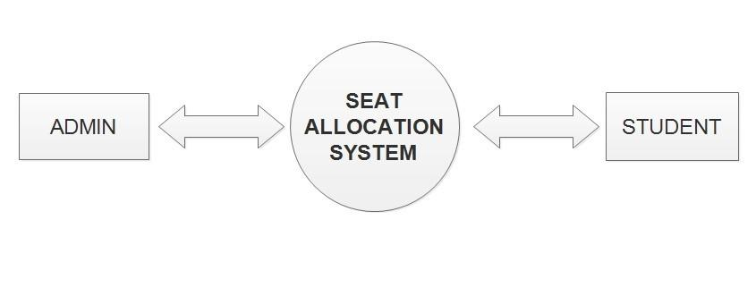

**Figure 1: Context Diagram**

7.2 DATA FLOW DIAGRAM

A data flow diagram (DFD) is a graphical representation of the "flow" of data through an information system, modelling its process aspects. We used DFD as a preliminary step to create an overview of the system, which can later be elaborated also be used for the visualization of data processing (structured design) .

9

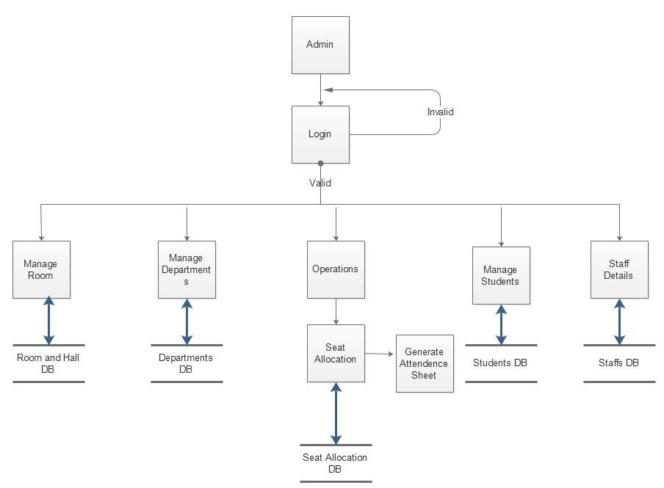

Figure 2: Data Flow Diagram for admin

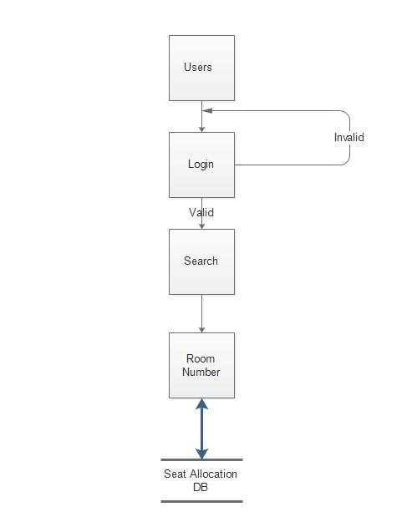

Figure 3: Data Flow Diagram for user

10

7.3 USE CASE DIAGRAM

A use case diagram at its simplest is a representation of a user's interaction with the system that shows the relationship between the user and the different use cases in which the user is involved. The actors for our system are: Admin and Students. The graphical representation of what our system must actually do is represented below:

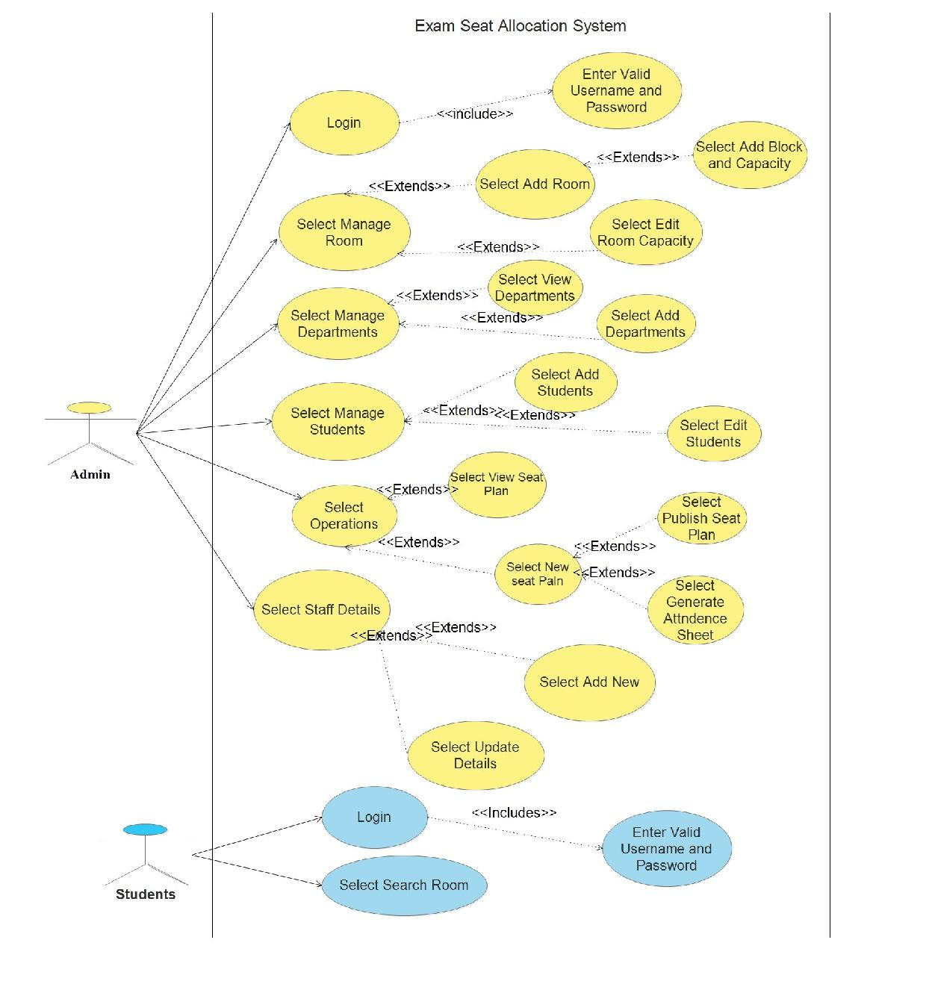

Figure 4: Use Case Diagram

11

7.4ACTIVITY DIAGRAMS

An activity diagram shows the flows from activity to activity within a system. An activity shows a set of activities, the sequential or branching flow activity to activity, and object that act and acted upon. Activity diagram shows what activities can be done in parallel, and any alternate paths through the flow. Activity diagrams contain activities, transitions between the activities, decision points, and synchronization bars. Activities diagrams emphasize the flow of control among object.

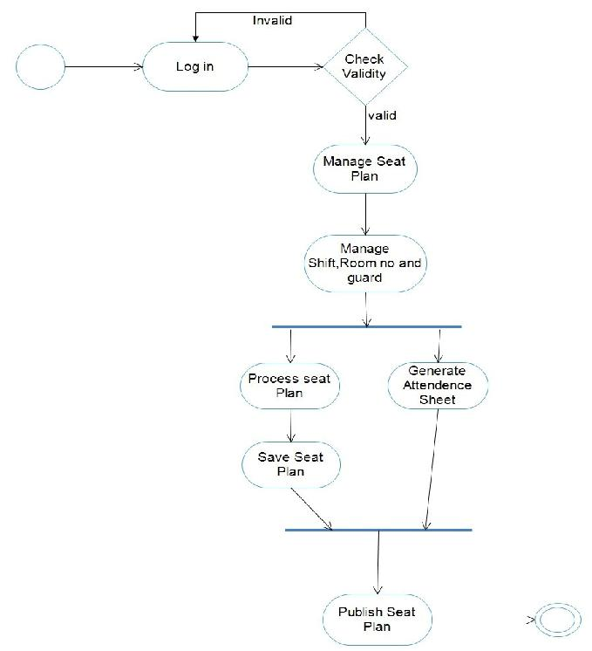

Figure 5: Activity diagram for admin

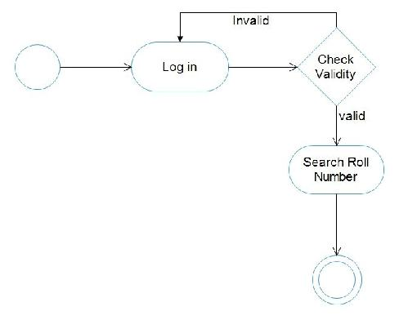

Figure 6: Activity diagram for user

12

7.5 SEQUENCE DIAGRAMS

Sequence Diagram is an interaction diagram. It show how the events occur and in what order. For our system we have designed sequence diagrams for most critical and influencial activities which are shown below.

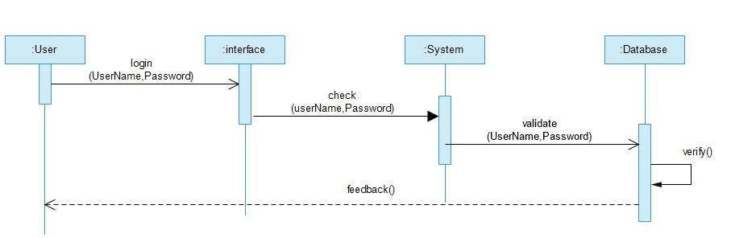

Figure 7: Sequence Diagram for Login

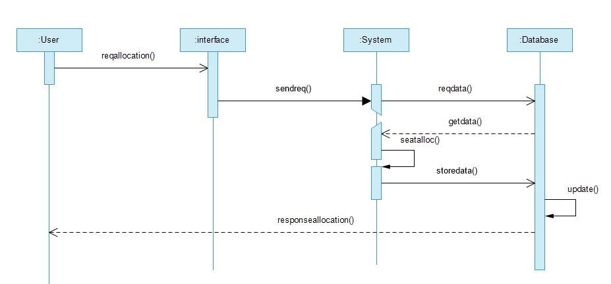

Figure 8: Sequence Diagram for seat allocation

13

7.6 ER DIAGRAM

Entity Relationship Diagram, also known as ERD, ER Diagram or ER model, is a type of structural diagram for use in database design. An ERD contains different symbols and connectors that visualize two important information’s. The major entities within the system scope and the inter-relationships among these entities is shown in the figure below:

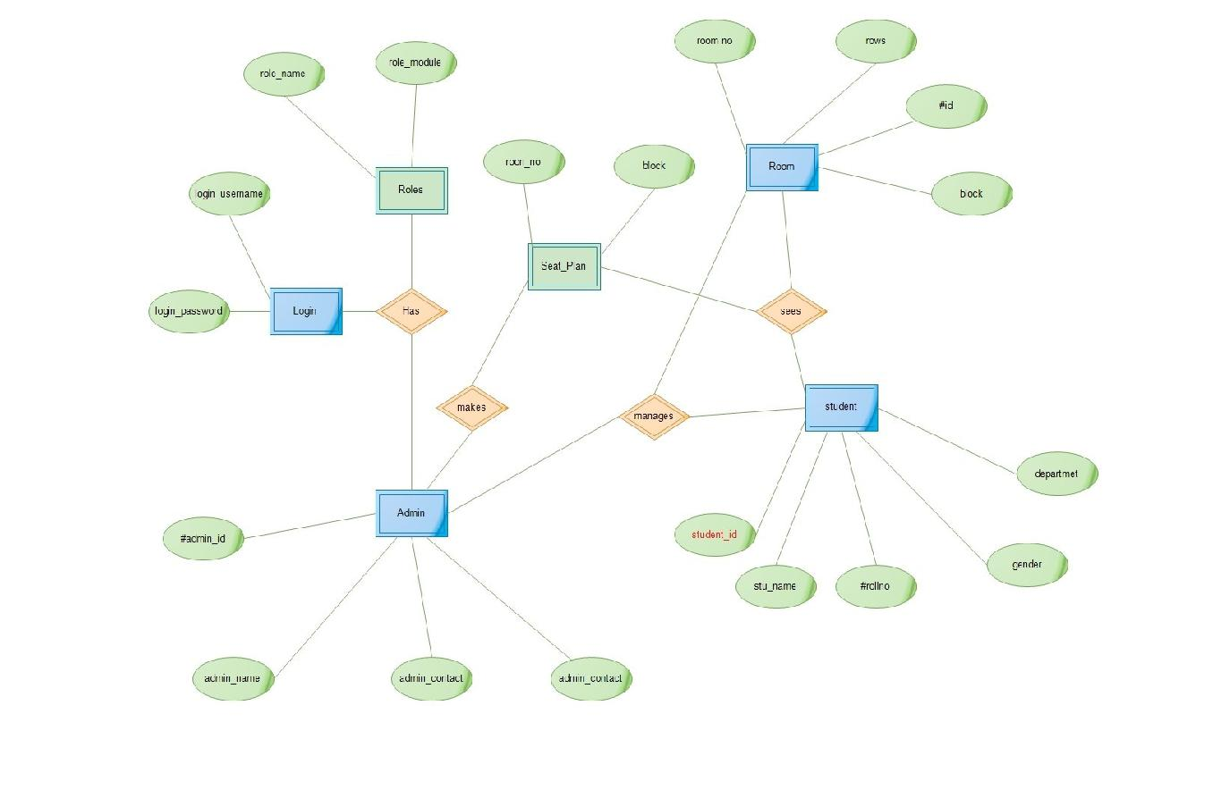

Figure 9: ER diagram

14

6.7 DOMAIN MODEL

A domain model is a system of abstractions that describes selected aspects of a sphere of knowledge, influence, or activity (a domain). First, we identified the major concepts (conceptual classes) in our project. The concepts include: User, Application, WebAPI, Google Maps API, EventScrapper and Events. Then we included the attributes of the conceptual classes and finally the associations between these concepts were identified.

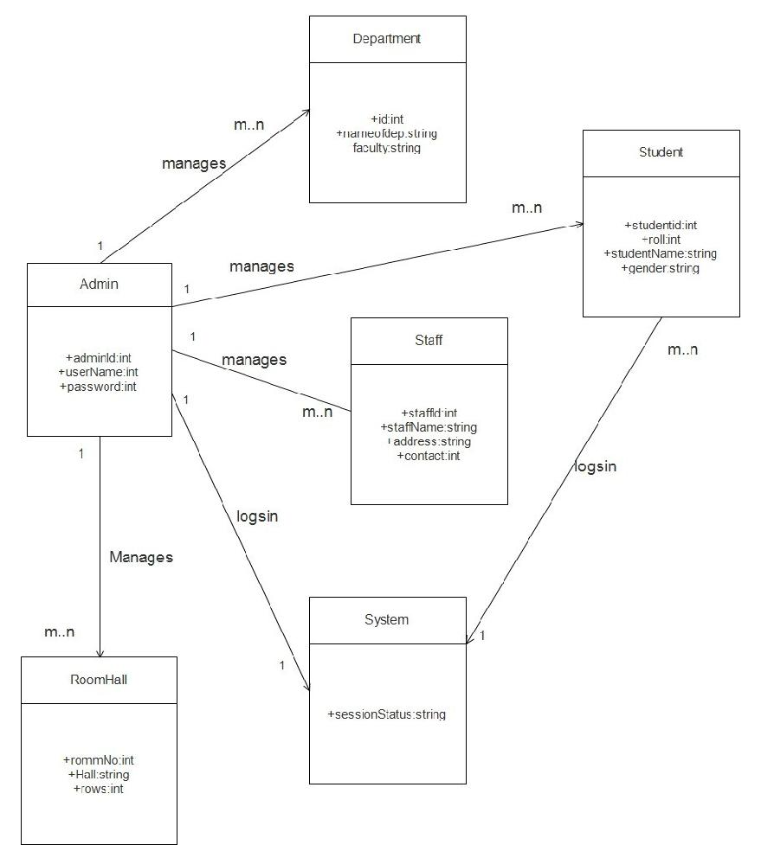

Figure 10: Domain Model

15

8.SECURING DATA IN WEB

The main problem while developing a web based application is lack of security . All the data is accessed in the web through our device while running this application and the data must be secured .The first thing we consider while data security is physical security i.e. securing data from thieves , natural disasters and other physical harm which may damage the data and may be misused if stolen by someone . The physical protection can be provided by guards and administration’s people . But these people cannot secure data in the web where we should give attention . The data in the web can be secured by following activities:

1.Securing data from sql injection

There have been many high visibility attacks against web applications that can be traced back to a SQL injection attack successfully stealing passwords. SQL injection is a code injection technique that might destroy our database . SQL injection is one of the most common web hacking techniques . SQL injection is the placement of malicious code in SQL statements, via web page input . This can be controlled by using prepared statements while coding.

2.The data in web need to be secure from unauthorized users and hackers too . The data can be secured by using firewall in our device so that the unwanted file doesn’t get into our device which may cause damage or loss of data.

* MD5 or any other standard hashing algorithms can be used to secure our login information more secure to avoid unauthorized access.

16

9.ALGORITHM USED

In this algorithm we manually give the starting room numbers and departments for the further process of the algorithm .Then the students list is retrived from database and the rows of each classroom too .Then system will generate the seat plan . The pseudo code is given here.

1.Input starting room number and departments

2.Then calculates the total number of students in those departments

3.calculate total_bench(row)

4.while(room > 0)

4.1.if total_bench<(studept1 OR studept2)

then seat is not enough

4.2.create matrix of row (i=n) * col(j=2)

4.2.1.if(j=1)

print eroll of dept1 else print eroll of dept2 4.3.room ++(i.e.id++)

4.4.if(( eroll1 and eroll2) == NULL)

then exit.

17

10. TASK DONE SO FAR

The basic requirement collection has been completed. Use case diagram, er diagram, context diagram, domain model has been designed. All the idea for the completion of the project has been gathered. The user interface for the system that is the part from which the user directly interacts with the system has been developed. The allocation part from admin module has been developed and the students file upload through excel file has been completed.

18

11. PROPOSED DELIVERABLES

This system is designed for easy access to all data of any specific person. The existing pattern follows manual insertion of data of any person but in this scenario the excel sheet provides the data and is dynamically stored in database for further manipulation. And gives easy access to allocate seat for any examination anytime within lesser period of time. These services are to be provided in inefficient, cost effective manner, with the goal of reducing the time and resources currently required for such tasks.

19

8. TASK REMAINING

The basic requirement of the project has been completed but the task for over all implementation and development of the system is remaining. The user module is under construction . And the attendence sheet generation is also remaining.

9. PROJECT TASK AND TIME SHEDULE

The project schedule has been designed as per requirement and constraints involved. This project is schedule to be completed in about 3 months. Requirements analysis has been given more emphasis. Research and database management is to be done first and well document. Debugging and testing is to be done prior to the completion of project.

|  |  |
| --- | --- |
| TASKS | APPROX DURATION |
|  | (in days) |
|  |  |
| Requirement Analysis and Specification | 12 |
|  |  |
| Undertake Analysis of the System | 8 |
|  |  |
| Design System | 30 |
|  |  |
| Procedure Requirement Specification | 12 |
|  |  |
| Testing and Debugging | 12 |
|  |  |
| Test System Modules | 8 |
|  |  |
| Overall System Test | 8 |
|  |  |
| Develop Documentation | 15 |
|  |  |

Table 1: Project task and time schedule

20

TEAM MEMBERS AND DIVIDED ROLES

|  |  |  |  |  |  |
| --- | --- | --- | --- | --- | --- |
| Names | Roles | Responsibilities | |  |  |
|  |  |  |  |  |  |
|  |  | Develop | the | user | friendly |
|  | UI/UX Designer | Interface and | |  |  |
|  |  | work through design revision. | | | |
|  |  |  | | | |
|  |  | Testing the system Interface | | | |
|  |  |  |  | |  |
|  | System developer | Define | and | | execute |
| Santosh Thapa Magar |  | development requirement | | | |
|  |  | Discuss | and | determine the | |
|  |  | good workflow. | |  |  |
|  |  |  | | | |
|  | Project management | Manage risk and issues. | | | |
|  |  | Responsibility to keep project | | | |
|  |  | on track. |  |  |  |
|  |  |  | | | |
|  |  | Manage risk and issues in | | | |
|  |  | ongoing project tasks. | | |  |
|  |  |  | | | |
|  | Project management | Review and repeatative testing | | | |
| Bikash Thapa Magar |  | Responsibility to keep project | | | |
|  |  | on track. |  |  |  |
|  |  |  |  |  | |
|  | End User Documentation | Develop | the | documentation | |
|  |  | file. |  |  |  |
|  |  |  | | |  |
|  |  | Participate in testing. | | |  |
|  |  |  |  |  |  |

Table 2: Team members and divided roles

21

9.1. GANTT CHART

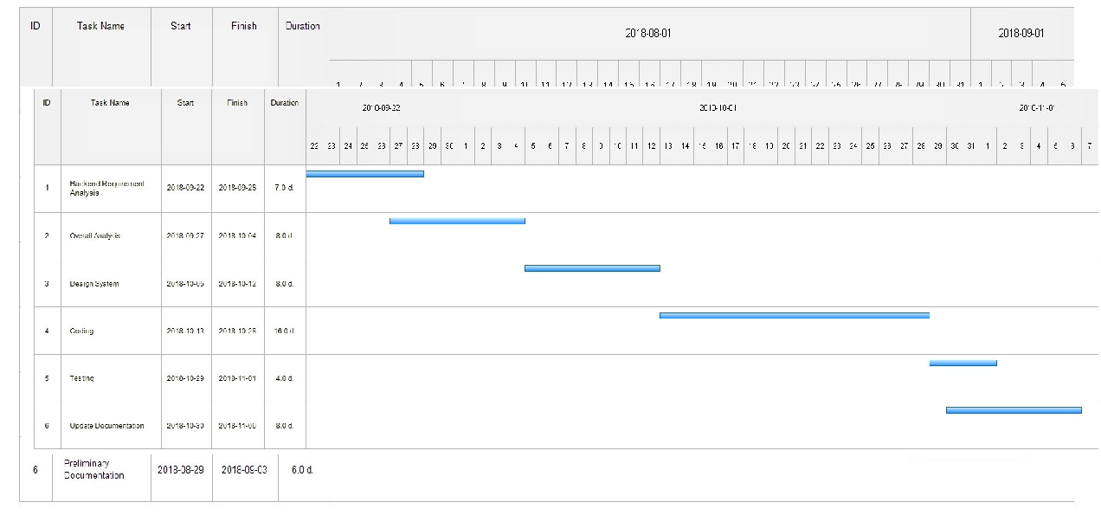

Table 3: Gantt chart first phase

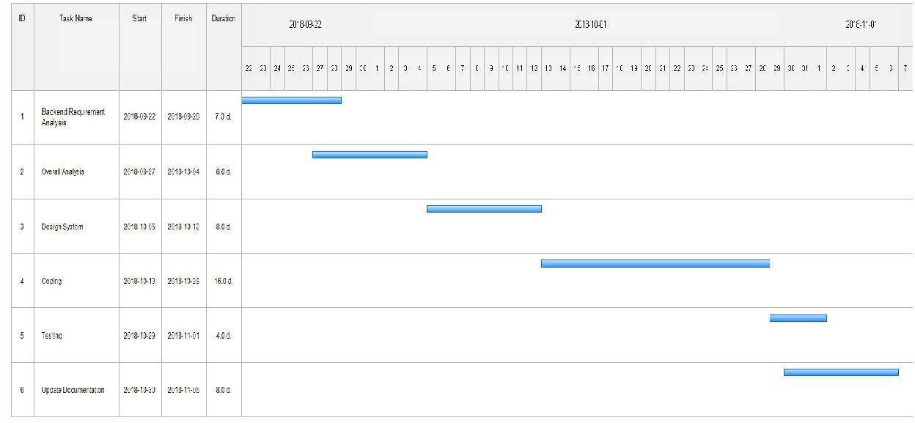

Table 4: gantt chart second phase

22

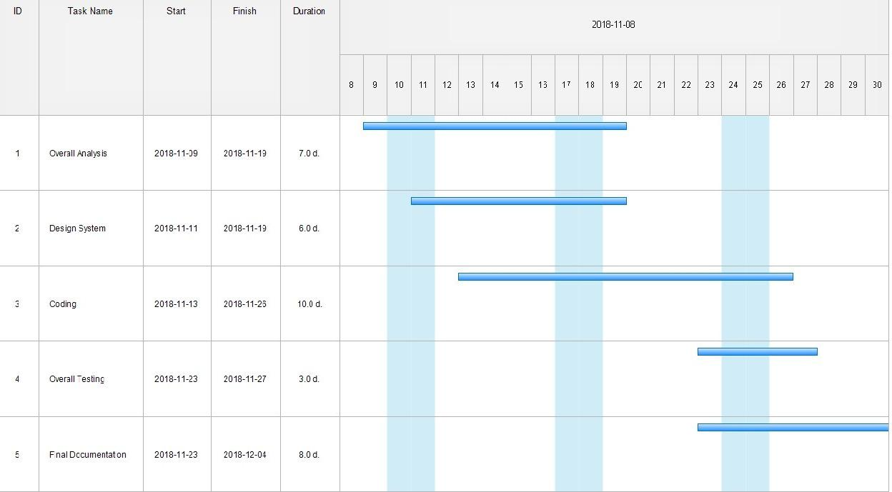

Table 5: gantt chart third phase

23

8. REFERENCES

[1] “Official Learning site” Available at <https://www.w3schools.com/>[Accessed:28-July-2018]

1. “ Project Proposal Formats ” [Online] Available [https://drive.google.com/drive/u/1/folders/](https://drive.google.com/drive/u/1/folders/0By46xMRiORSmS05EZEdsaTZGNzQ) [0By46xMRiORSmS05EZEdsaTZGNzQ](https://drive.google.com/drive/u/1/folders/0By46xMRiORSmS05EZEdsaTZGNzQ) [ Accessed: 24-Nov-2018]

[3]Reger S.Pressman, Ph.D.Seventh Edition, Software Engineering: A Practitioner’s Approach, McGraw Hill, 2010

[4]Database Connection Tutorials Available at https://www.w3schools.com/php/php_mysql_connect.asp [Accessed: 1-Aug-2018]

[5]Concept of building secure web application Available at <https://www.itproportal.com/2013/08/06/7-steps-for-building-a-secure-web-application/> [Accessed :10-Nov-2018]

[6]Computational Models for Examination Fraud Control Using Randomized

Algorithms , Monday Eze,Department of Computer Science/Mathematics/Informatics

[7]Dashboard template,https://colorlib.com/wp/free-bootstrap-admin-dashboard-templates/ [Accessed: October-16-2018].

[8]Reference for the project from IJRASET Available at [https://www.ijraset.com/fileserve.php?](https://www.ijraset.com/fileserve.php?FID=17021) [FID=17021](https://www.ijraset.com/fileserve.php?FID=17021) [Accessed :15-Sept-2018]

24